# ASSIGNMENT RESULTS - NIKITA

1.THE KING’S FEAST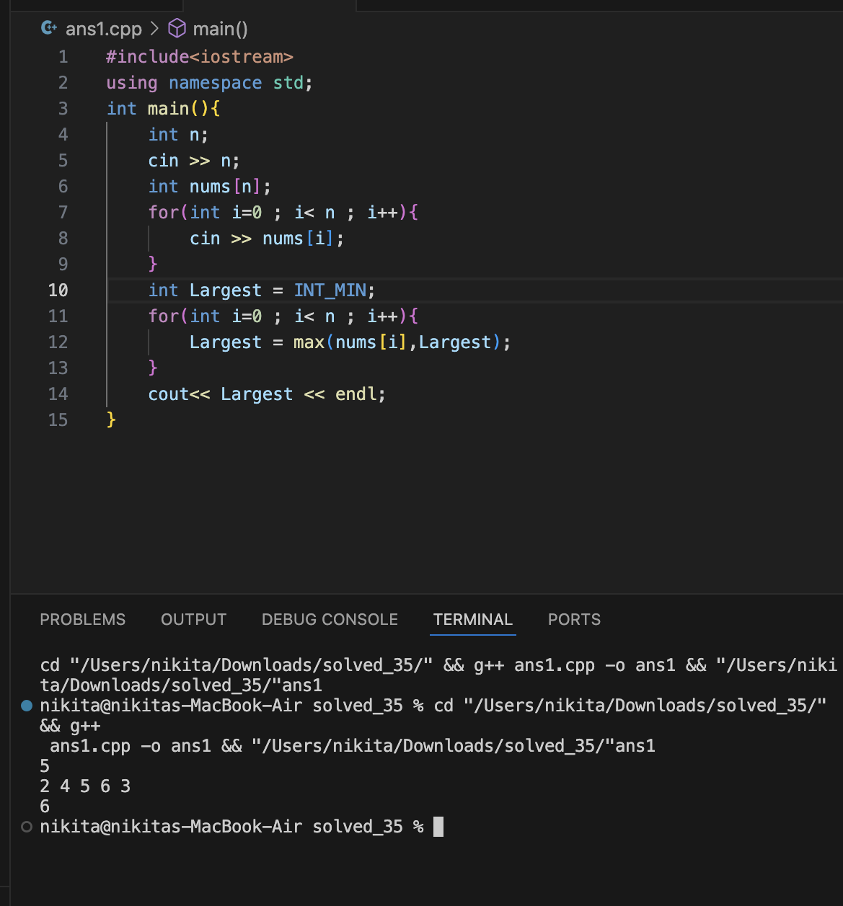

2.THE LOST SOLDIER

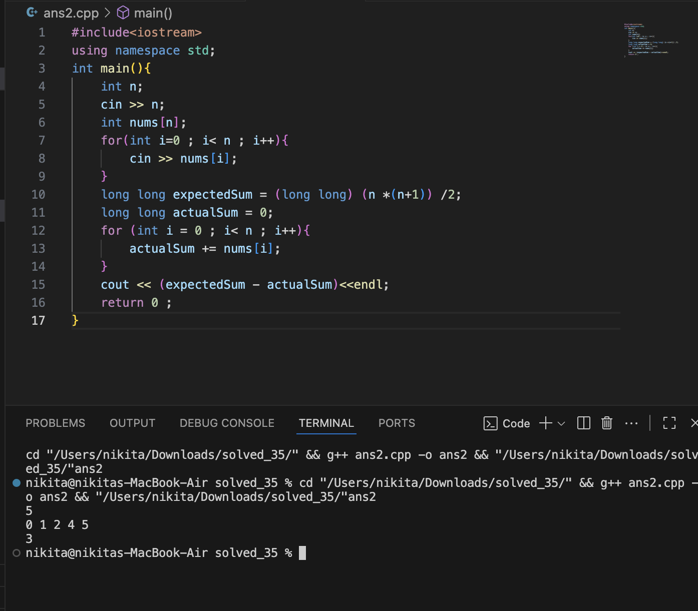

3. POTION MIXING

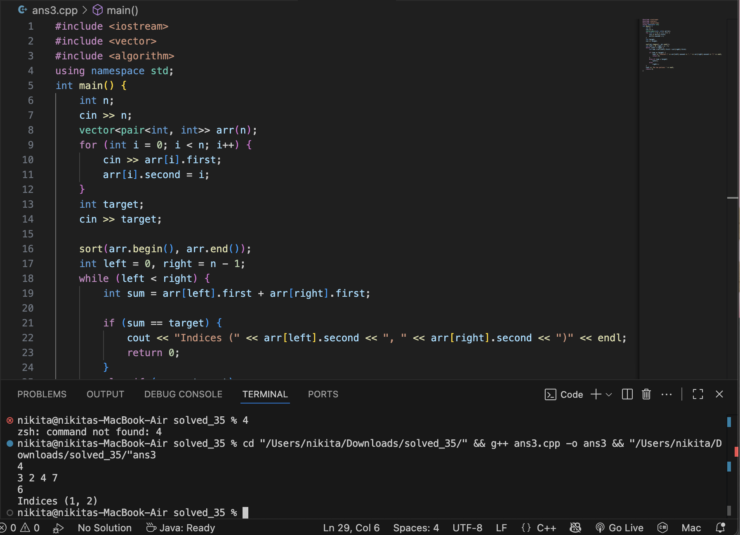

4.THE SECRET MESSAGE

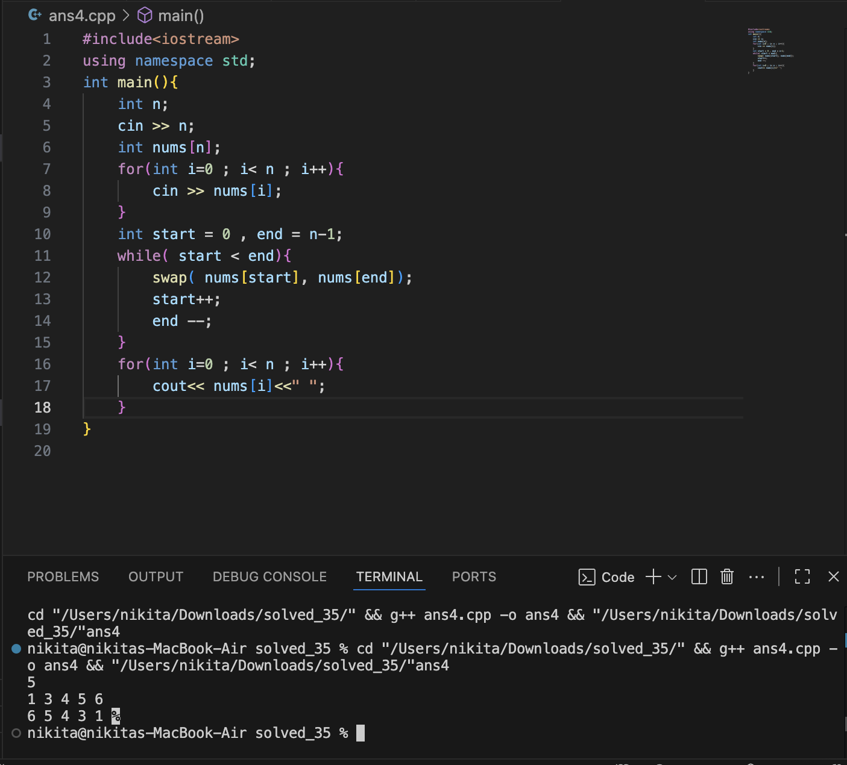

5. THE KING’S PARADE

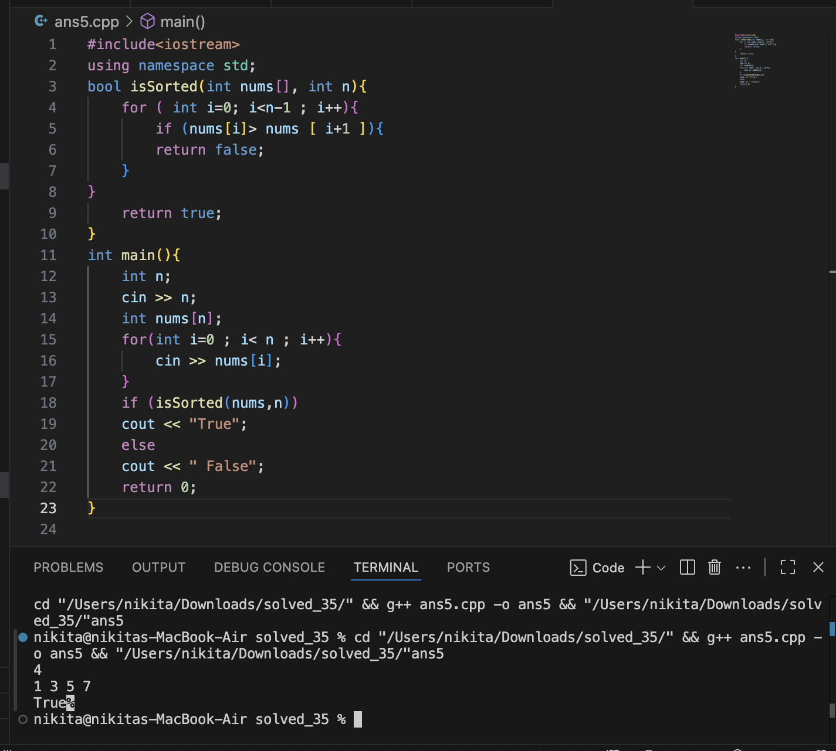

6.THE TREASURE ISLAND

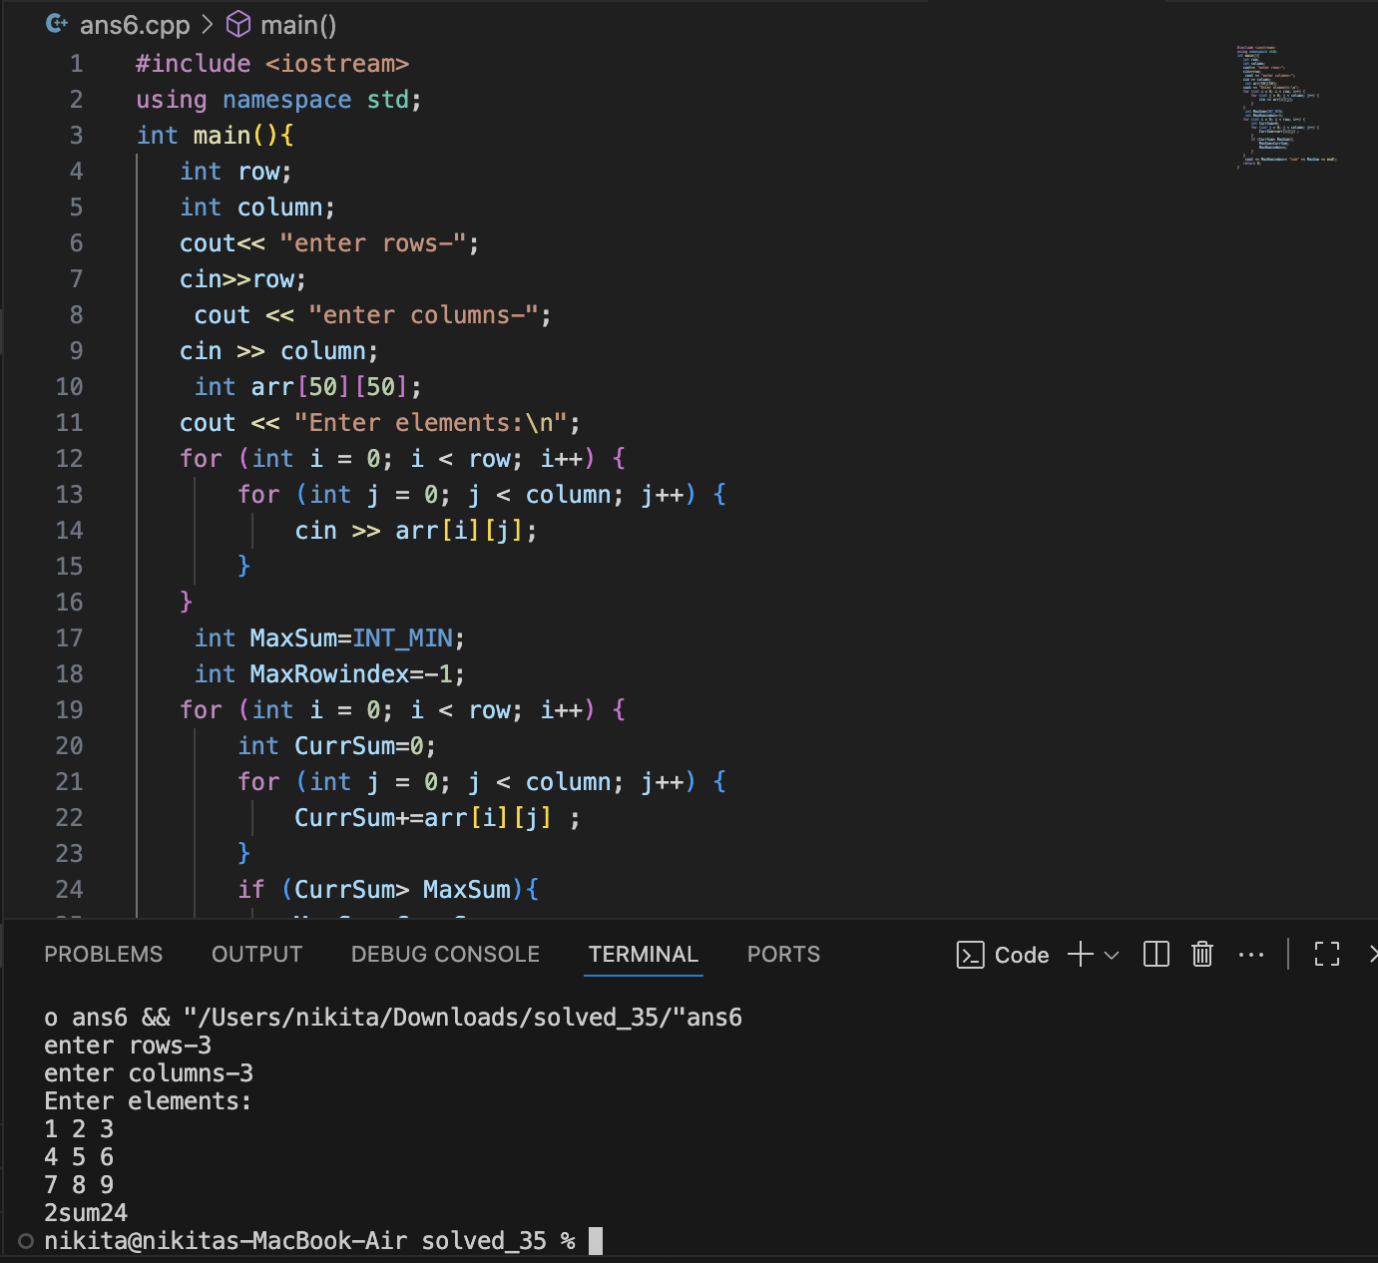

7. THE SPIRAL LIBRARY

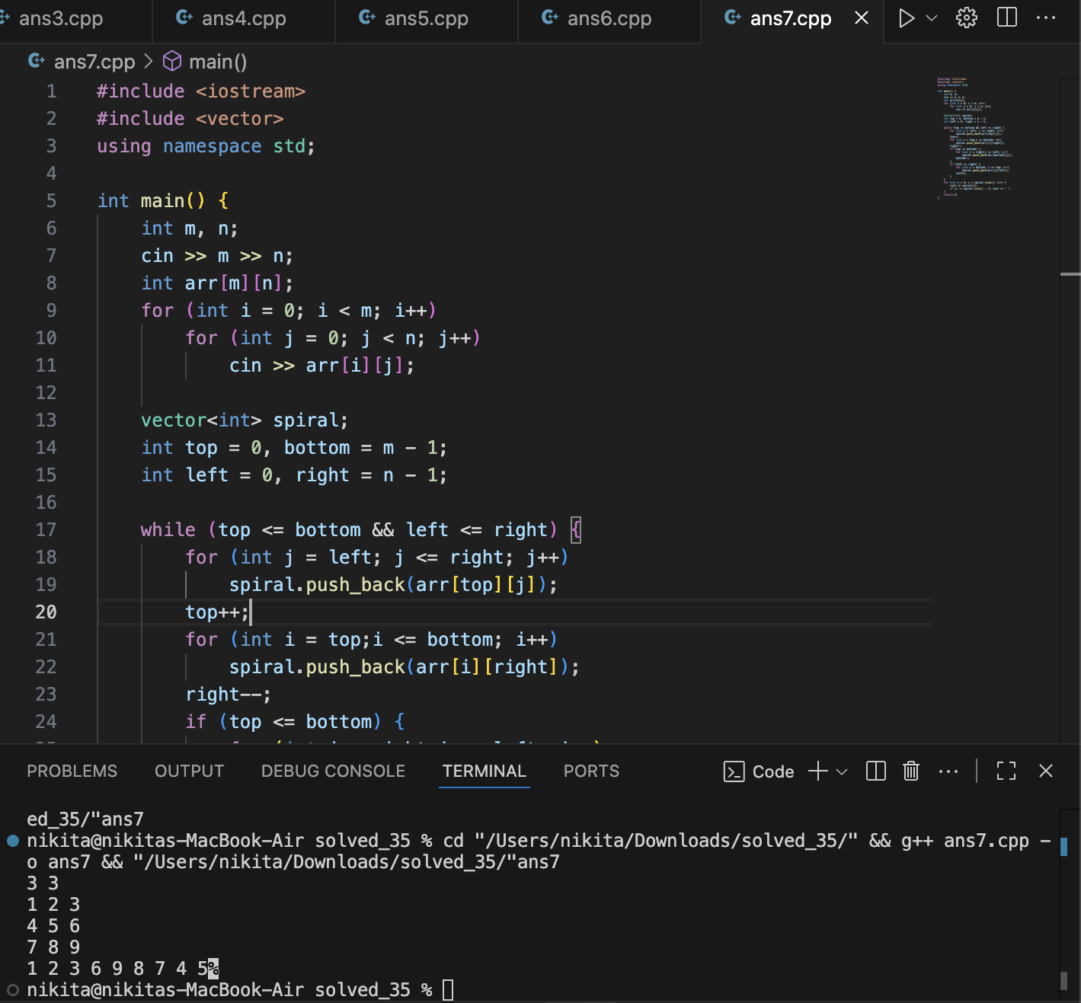

8. THE ROYAL DIAGONAL

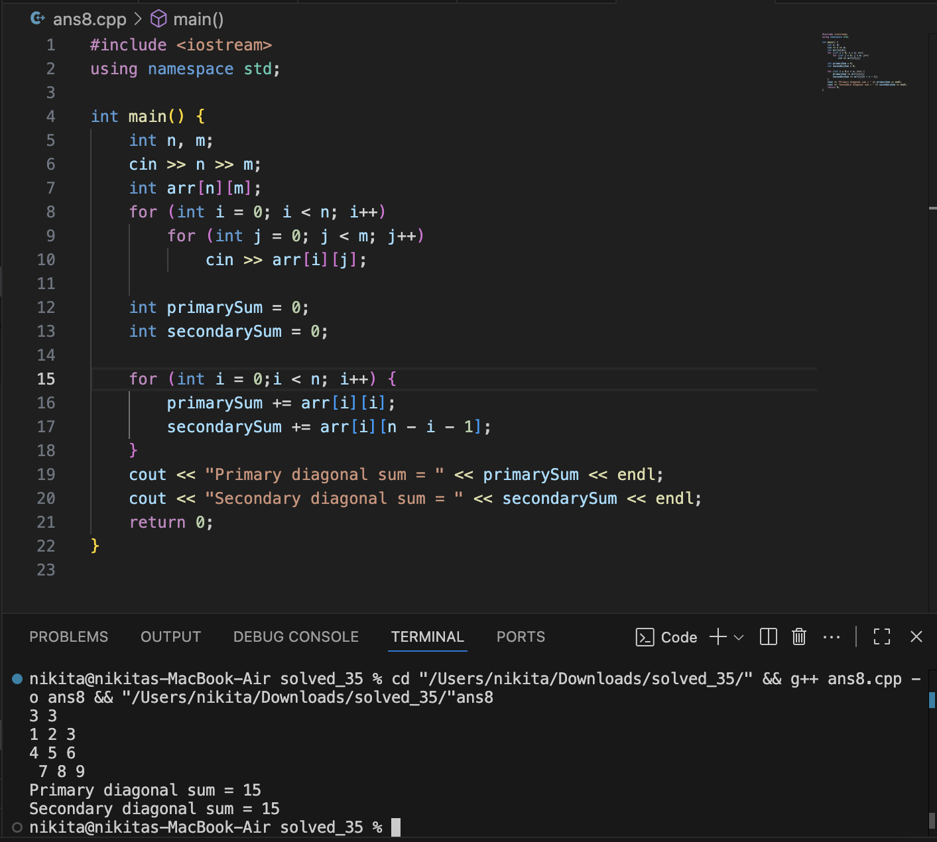

9. THE MESSENGER’S PATH

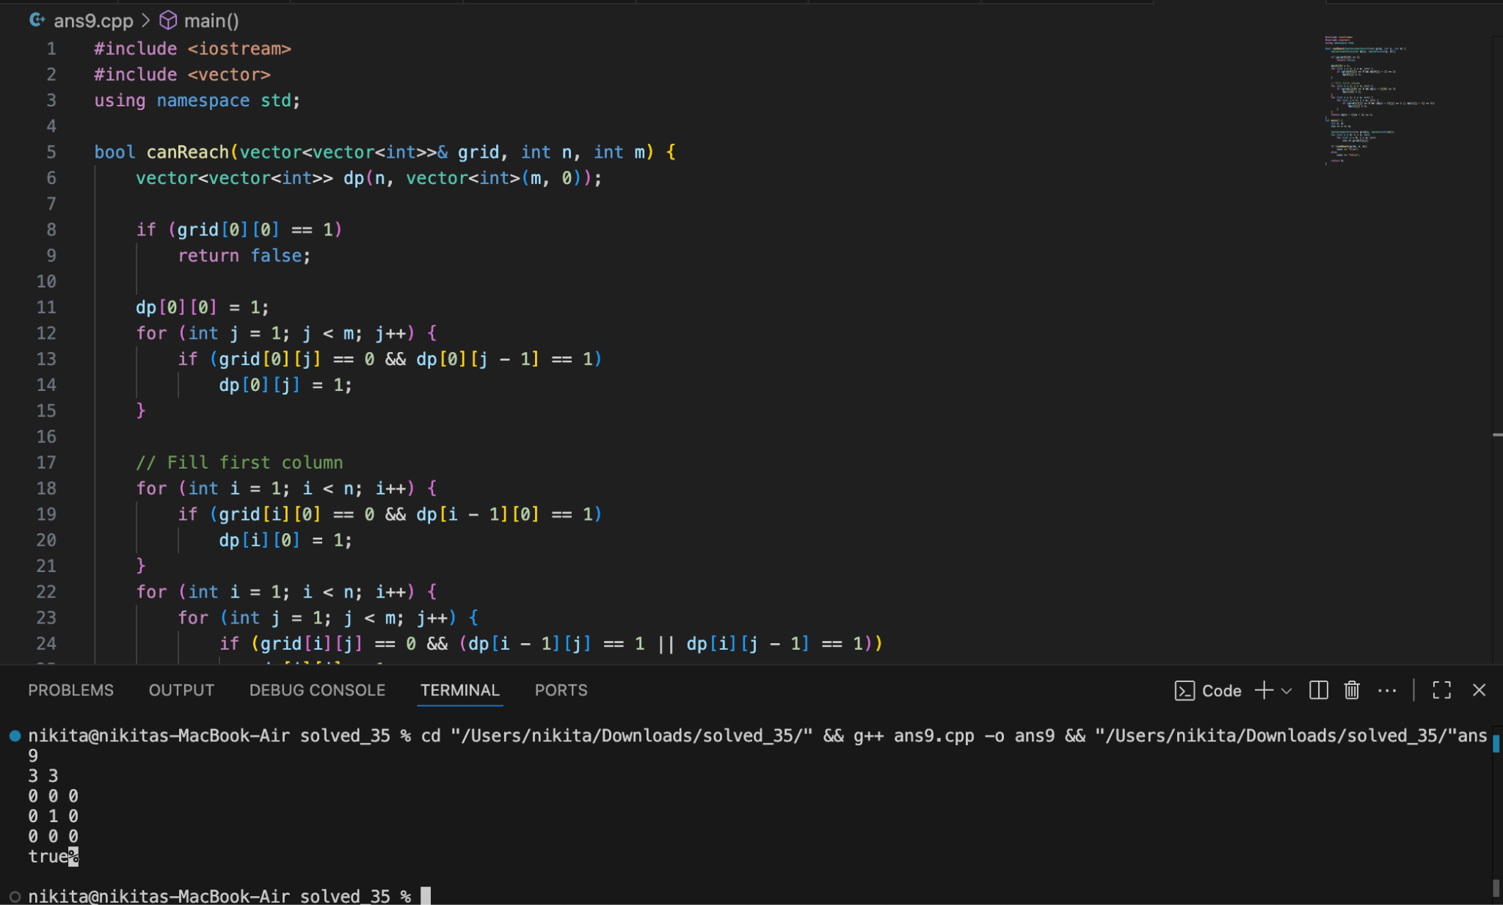

10. THE RAINWATER POND

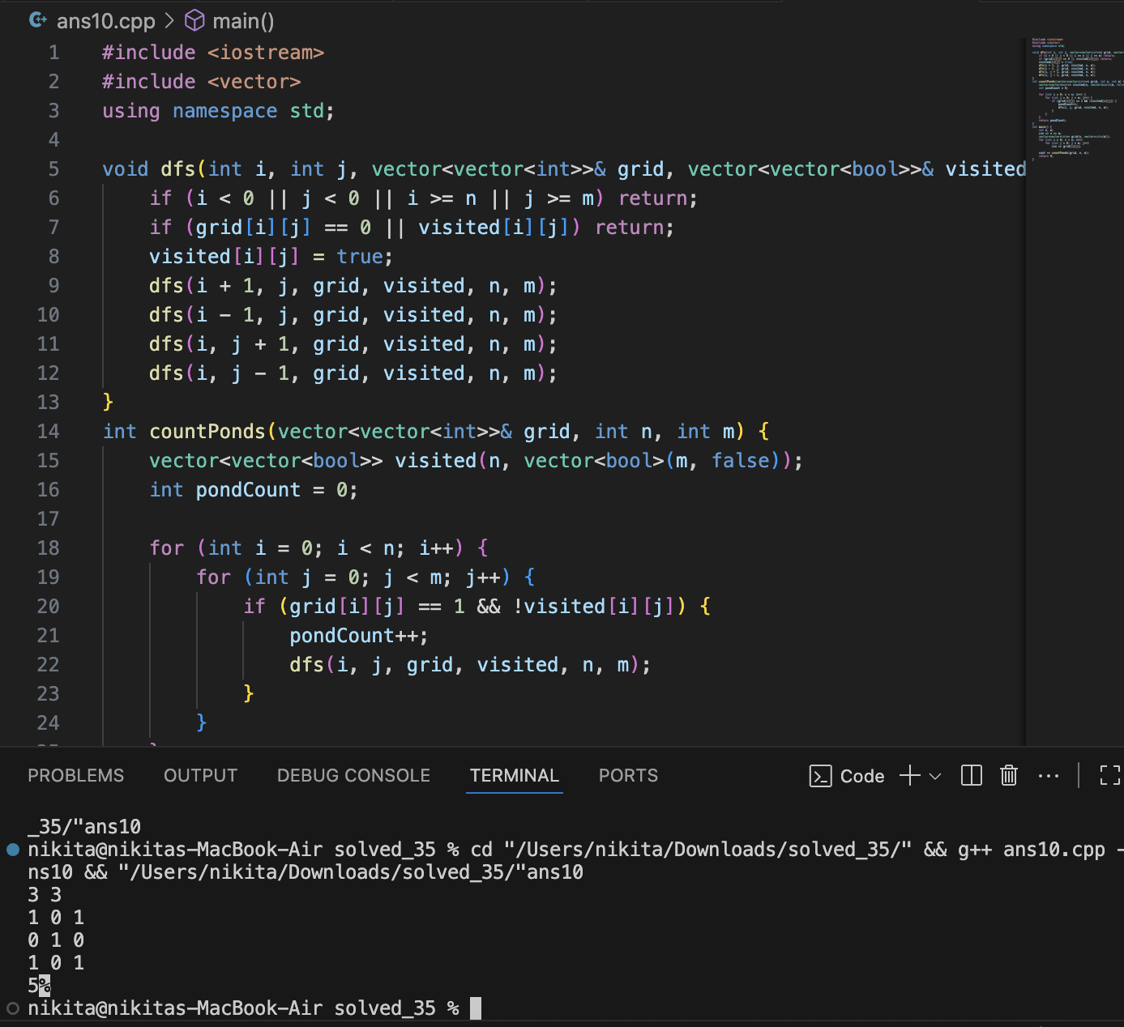

11. TOWER OF TEMPLES

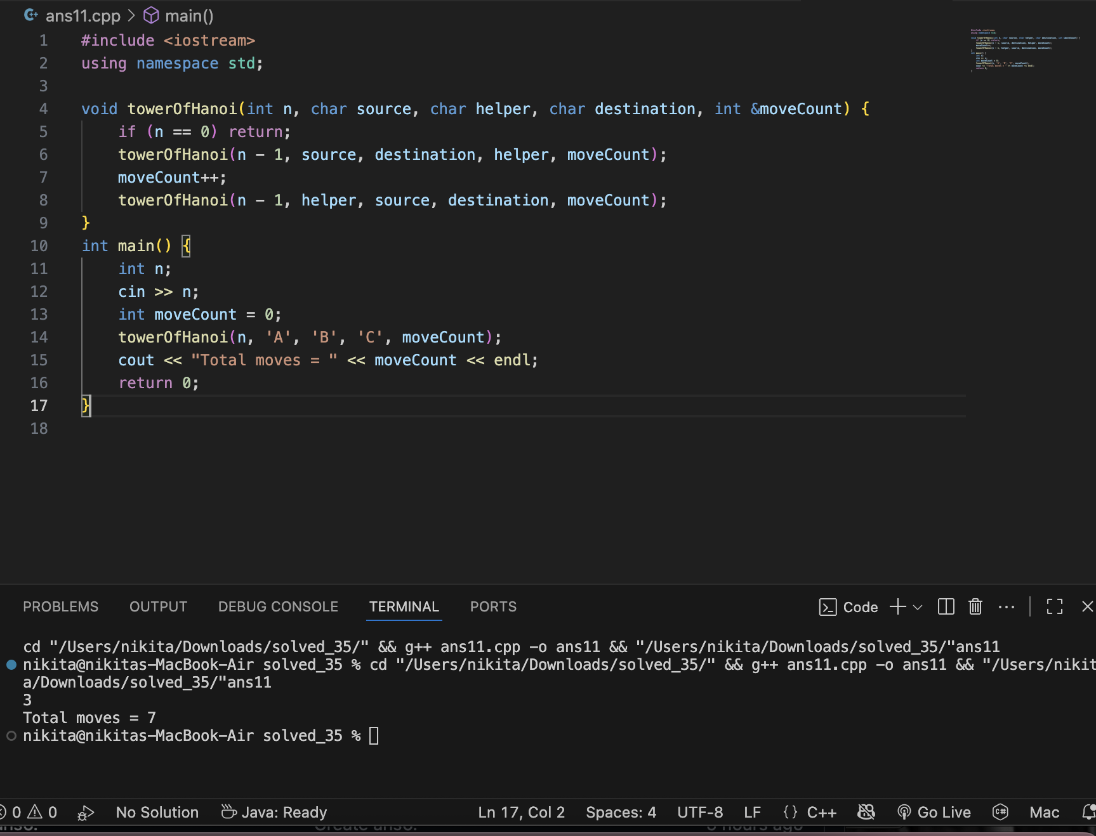

12.THE MAGICAL STAIRCASE

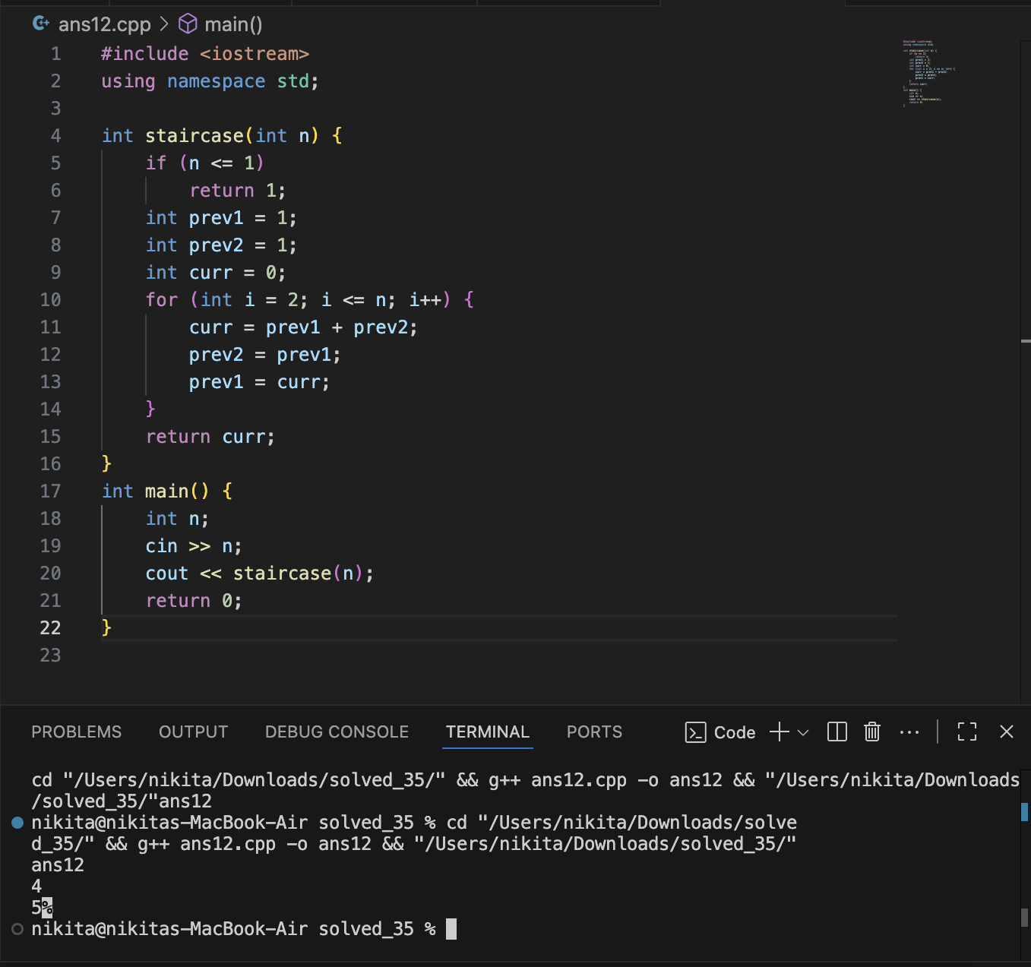

13.THE SORCERER’S SPELL

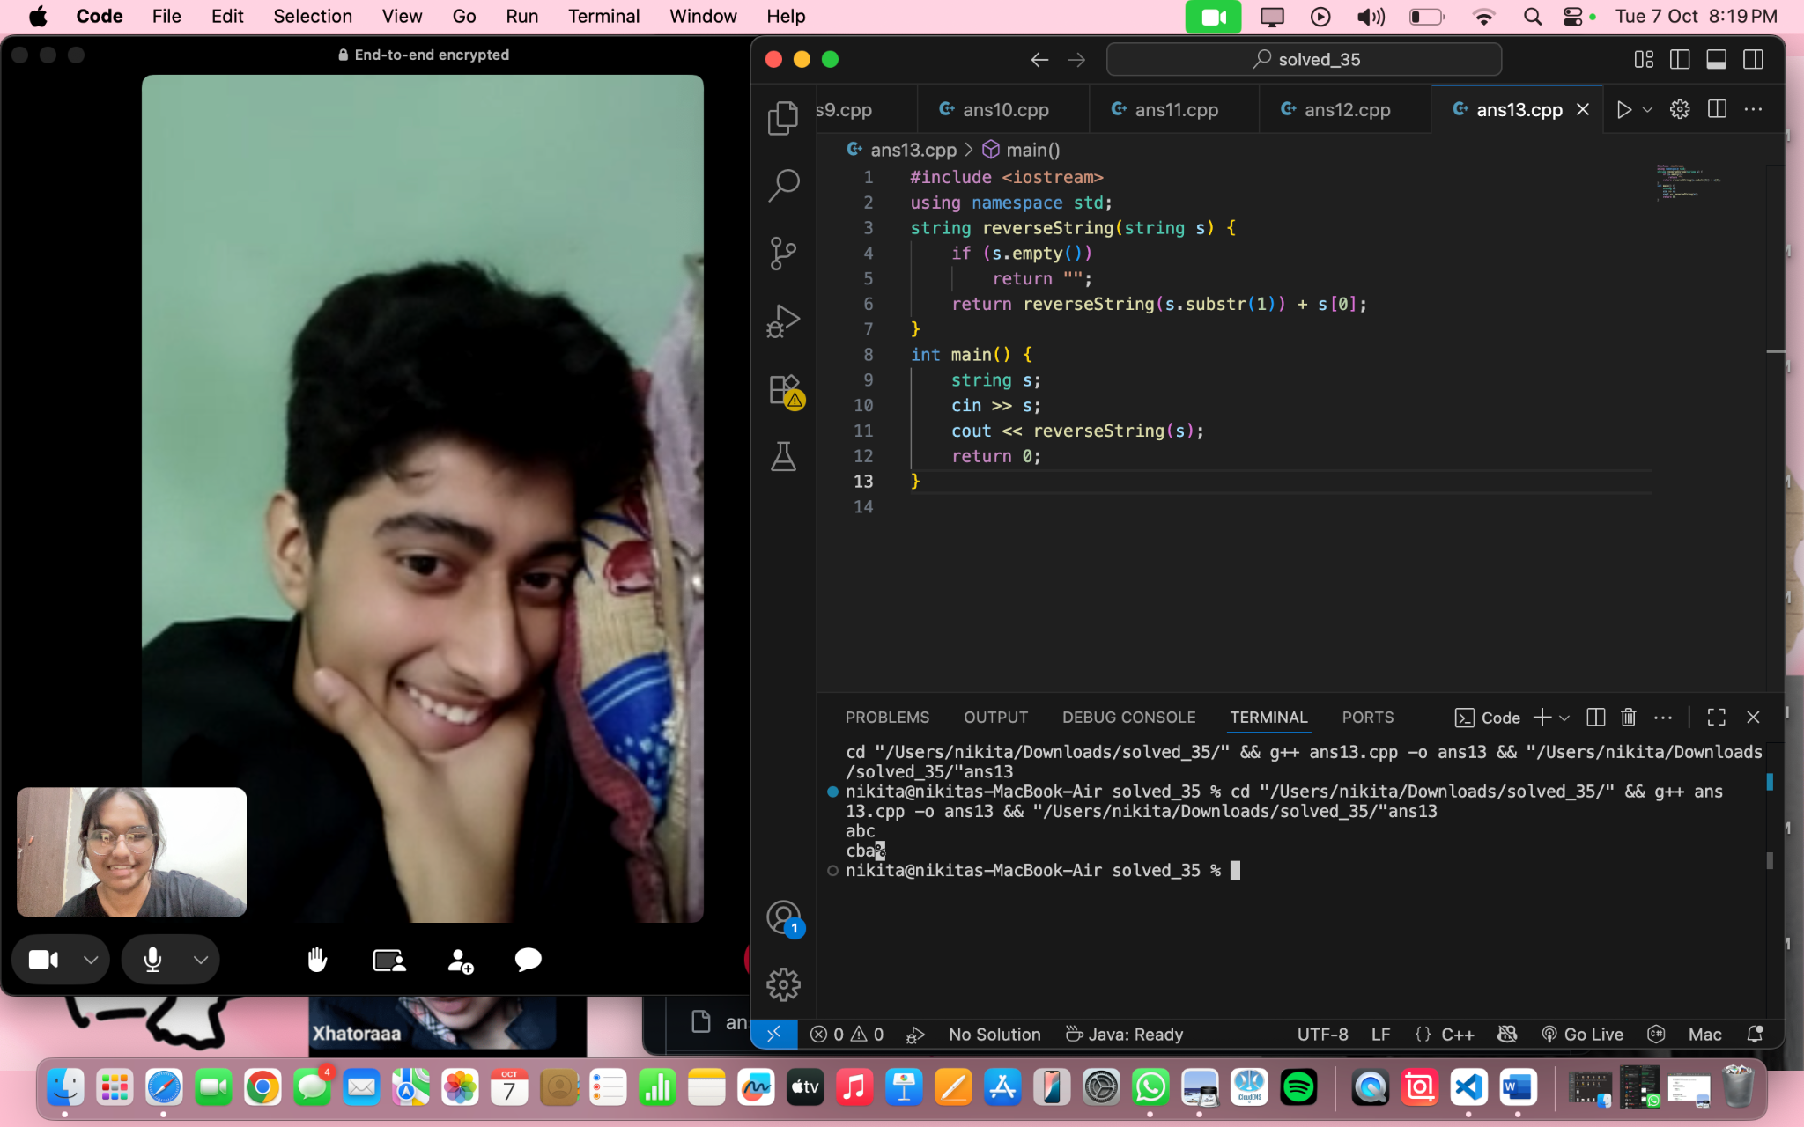

14.THE DRAGON’S ROAR

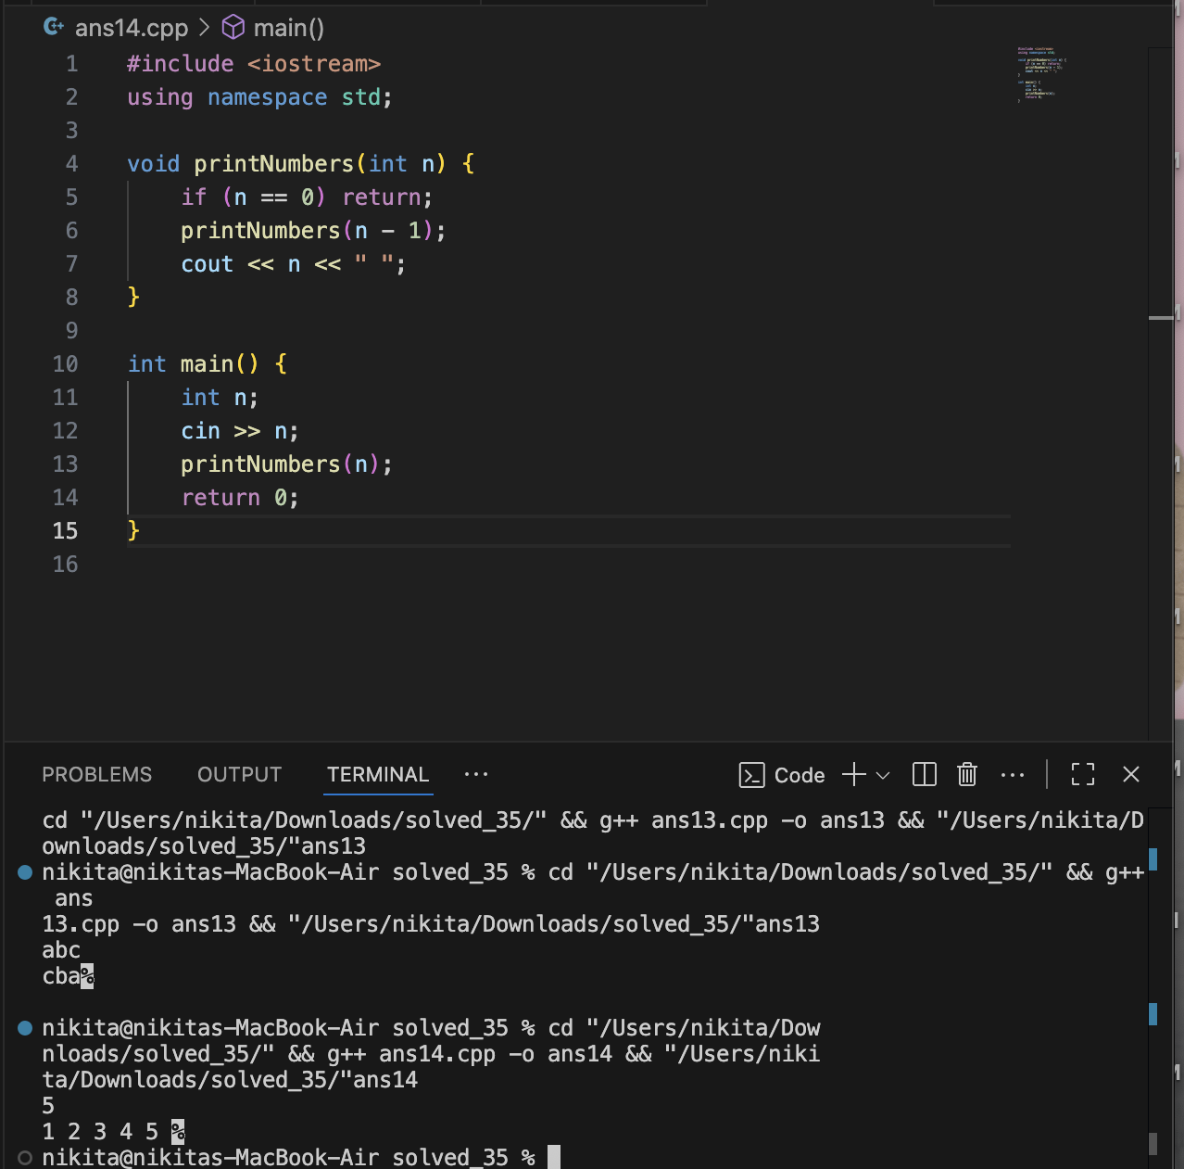

15. THE HIDDEN CHAMBER

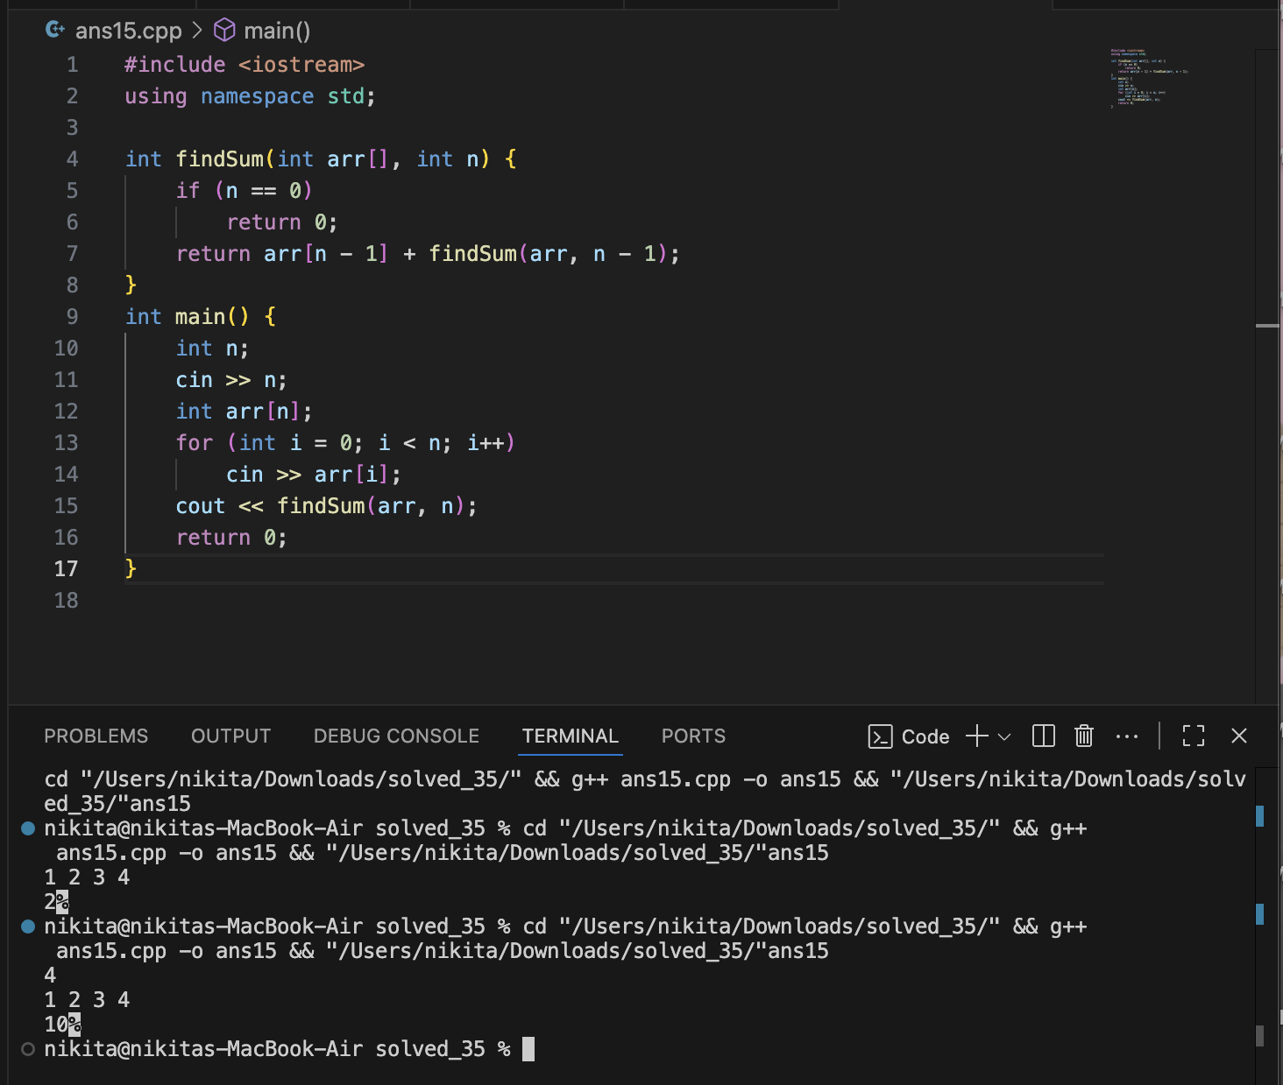

16. THE ANCIENT SCROLL

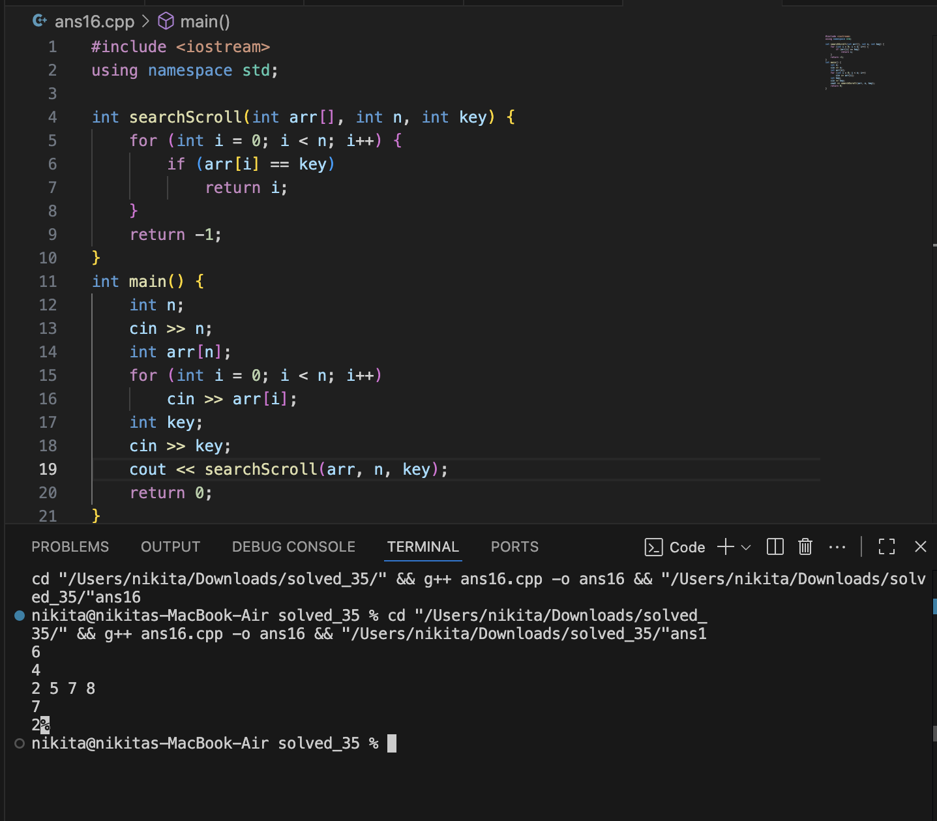

17. THE FARMER’S BASKET

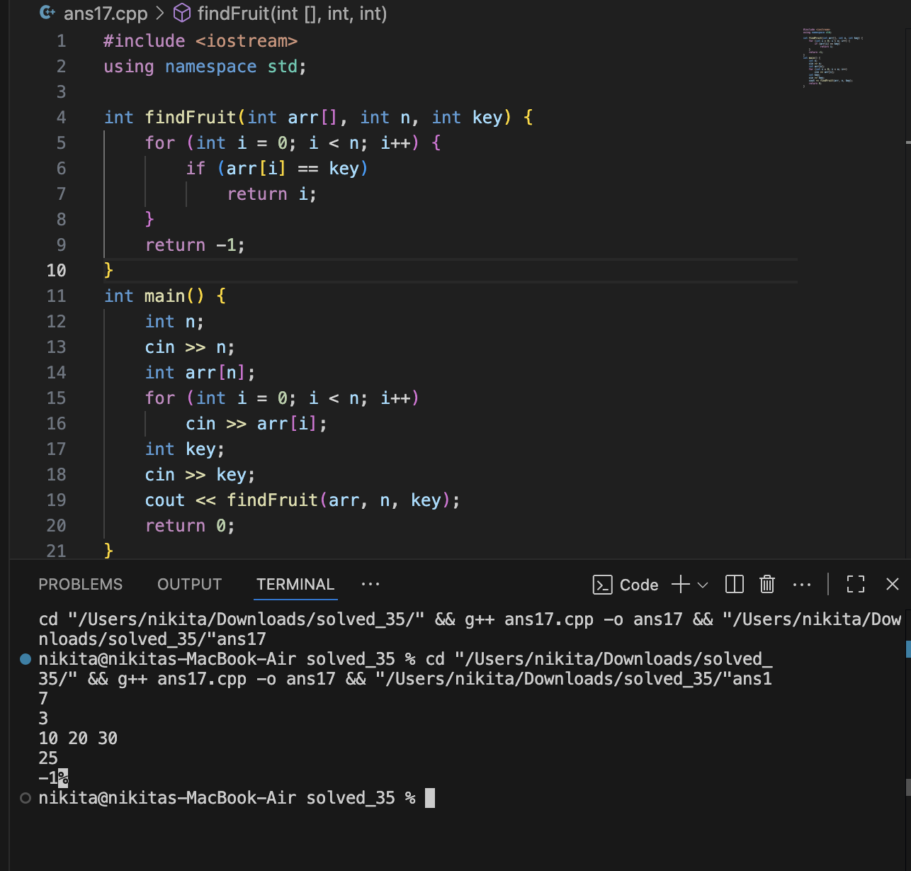

18. THE SECRET DOOR

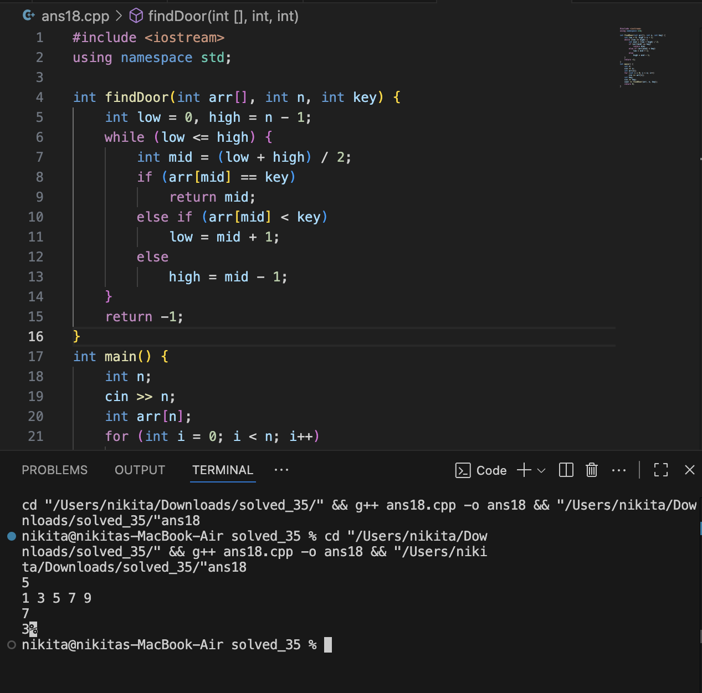

19. THE ARCHER’S RANGE

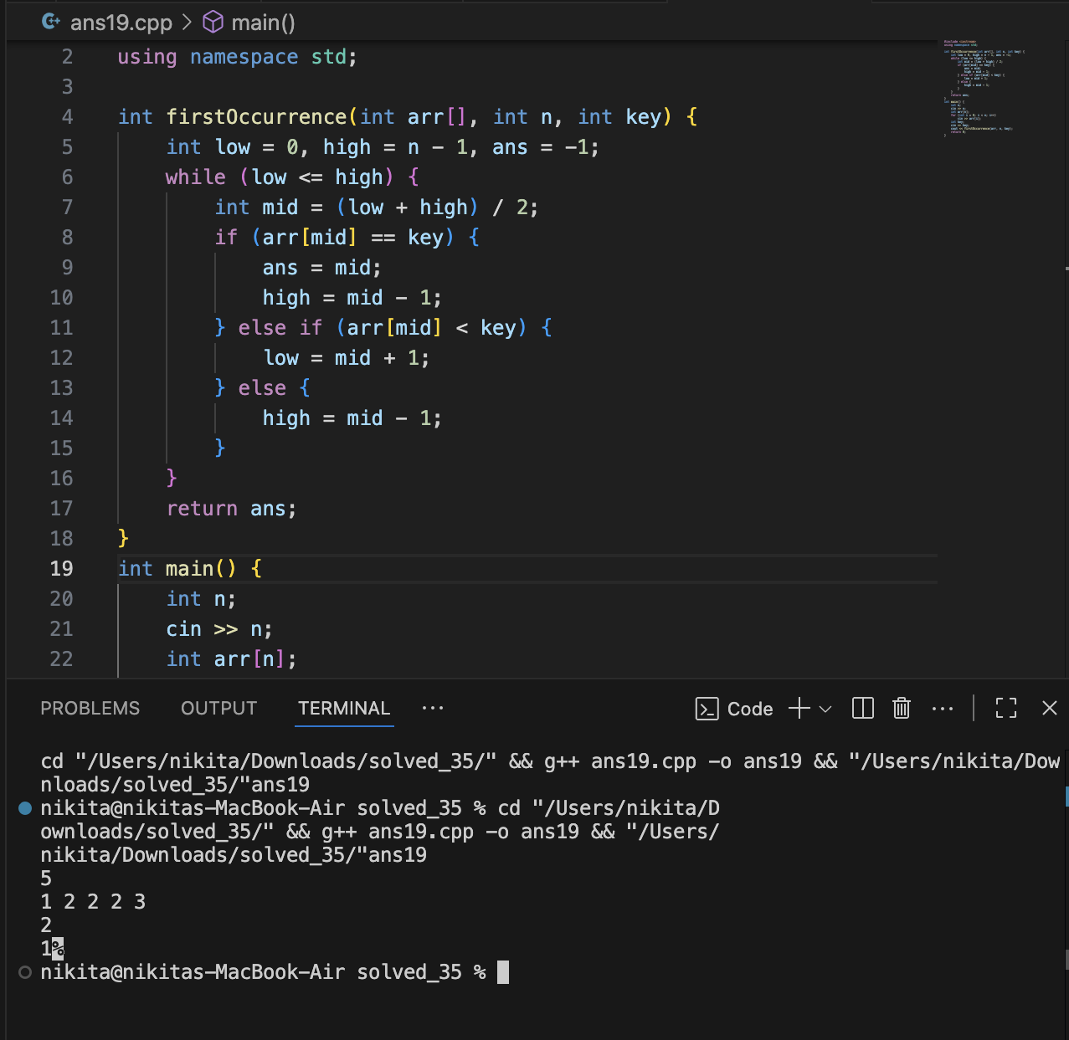

20. THE TREASURE CHEST

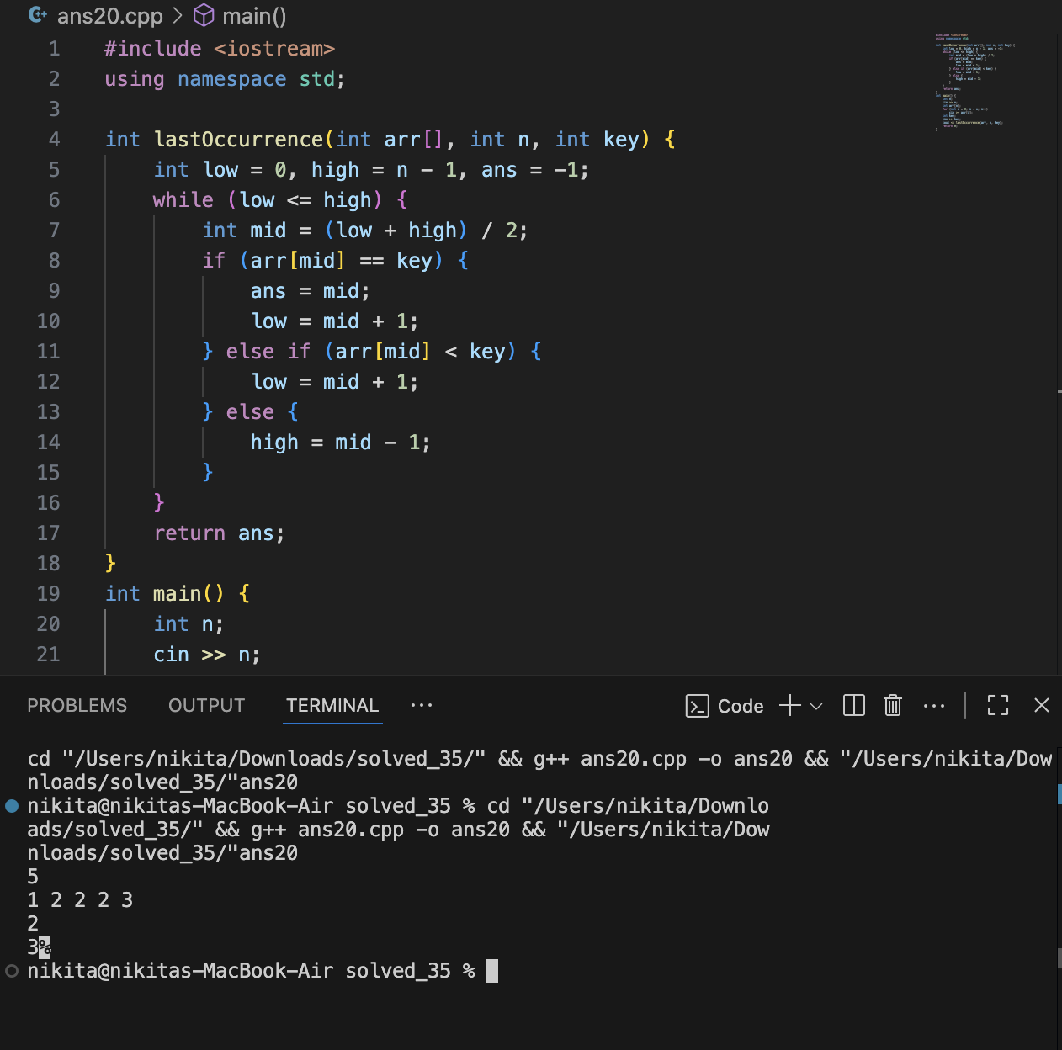

21. GREATER THAN OR EQUAL TO TARGET

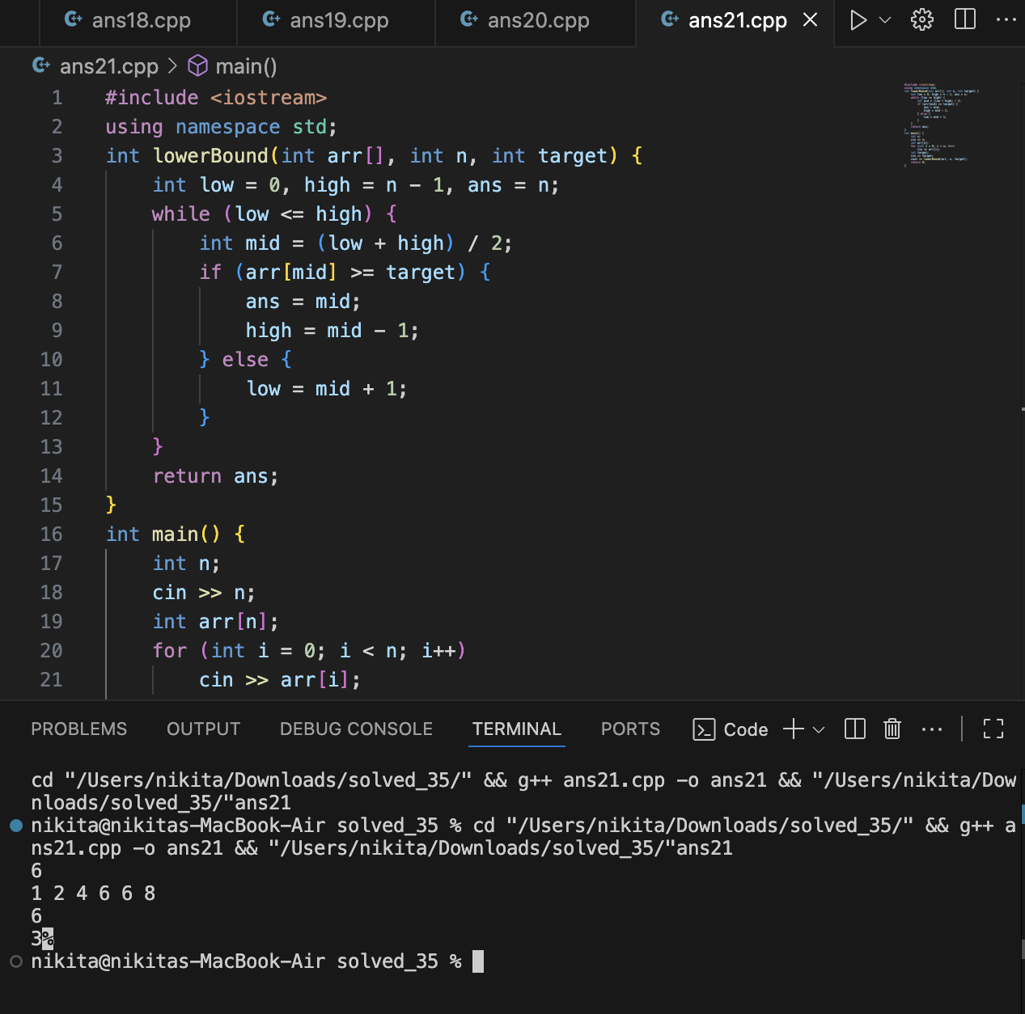

22. STRICTLY GREATER THAN TARGET

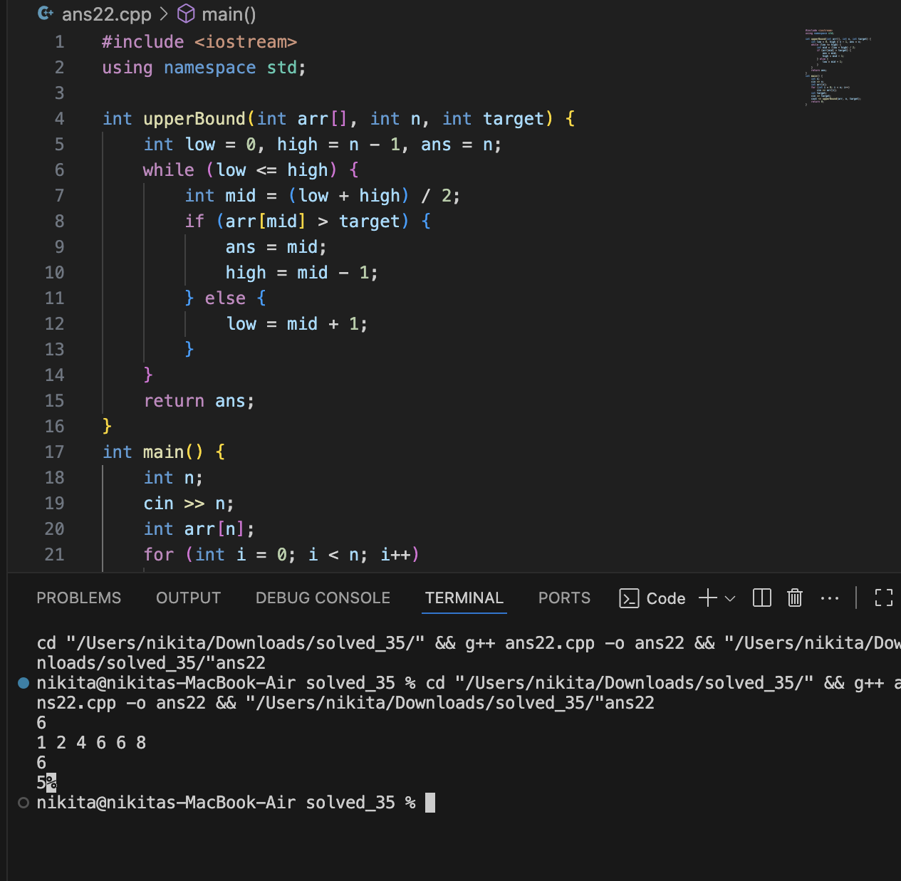

23. CEIL

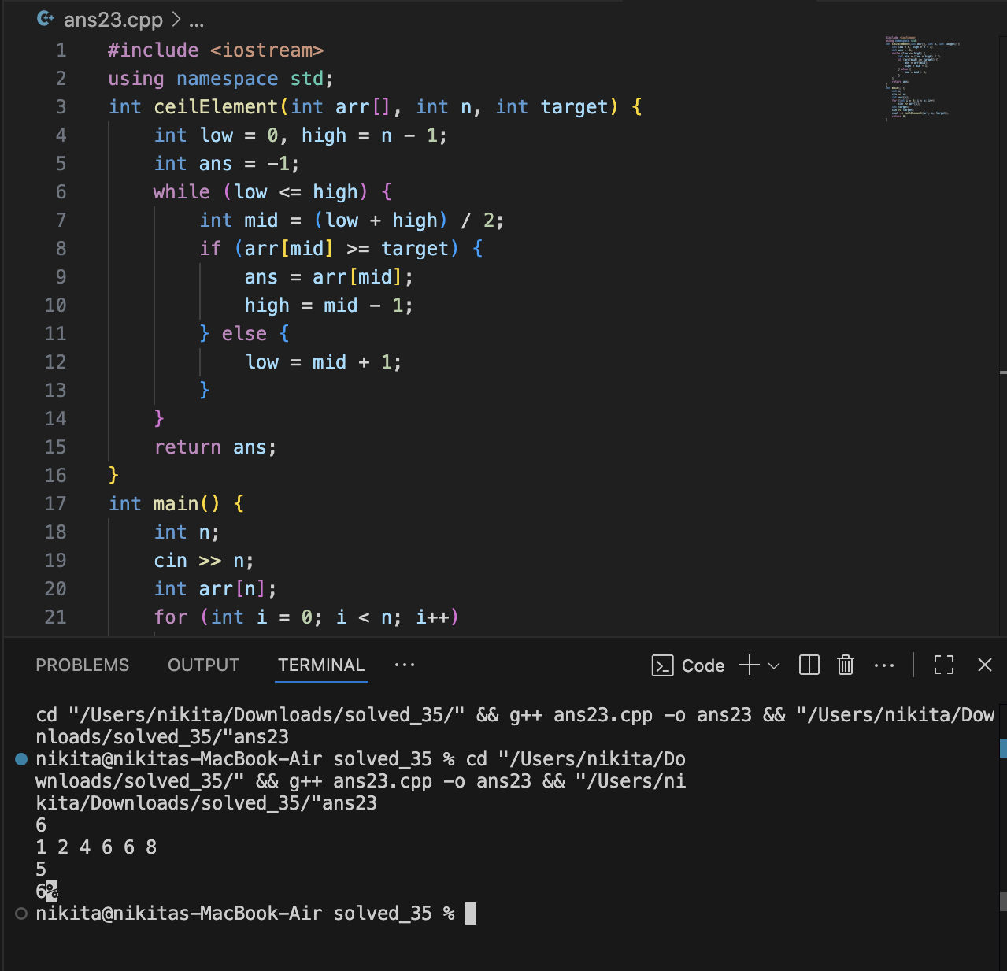

24. FLOOR

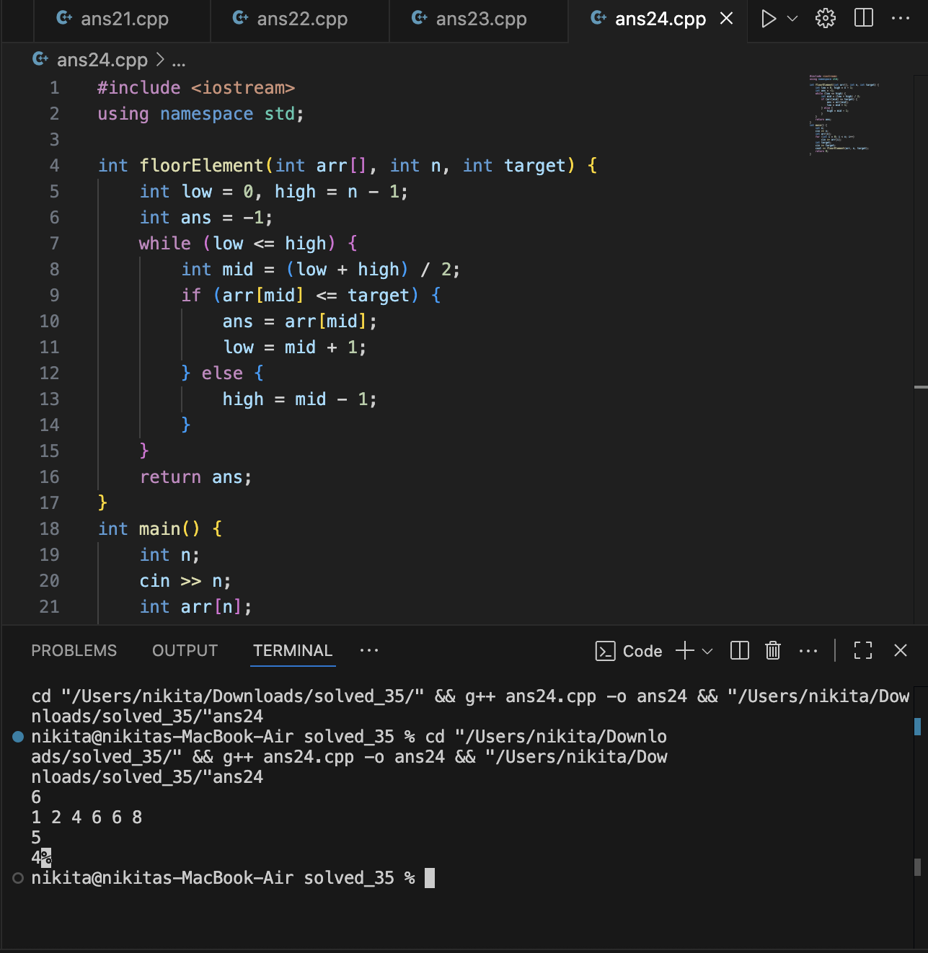

25. THE TREASURE MAP (LINEAR SEARCH)

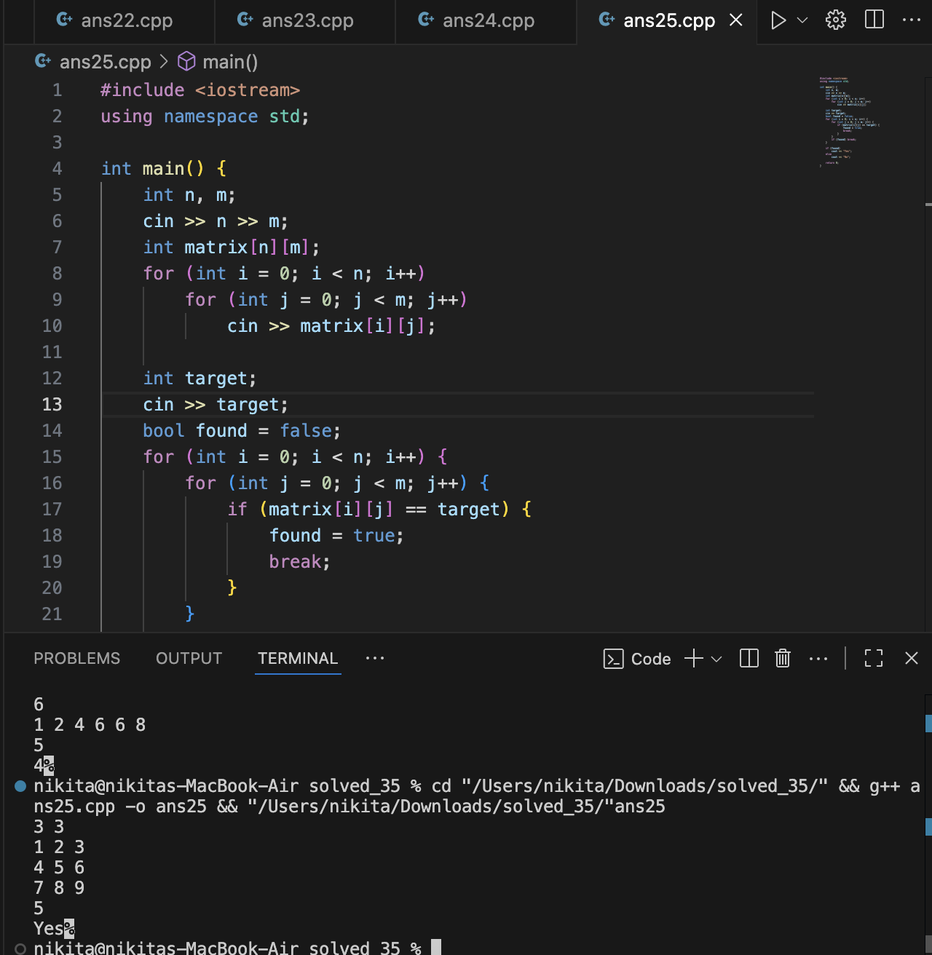

26. THE MAGICAL SCROLLS (LINEAR SEARCH RETURN INDEX)

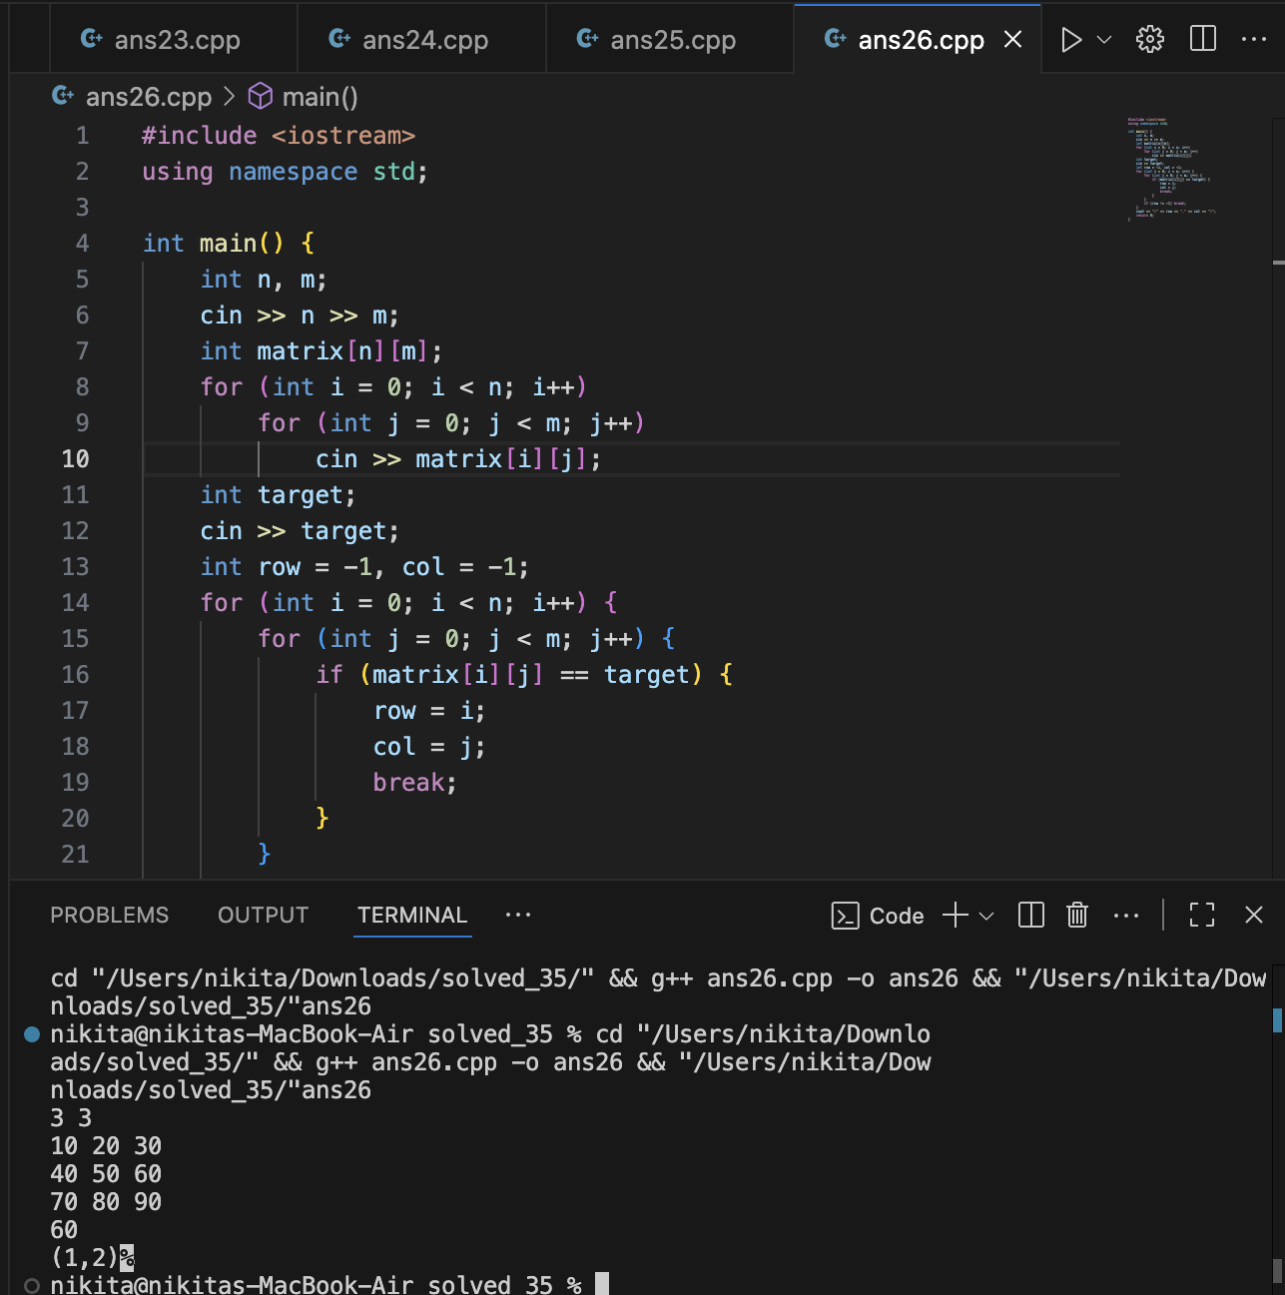

27.THE BATTLE FORMATION (BINARY SEARCH - FLATTENED)

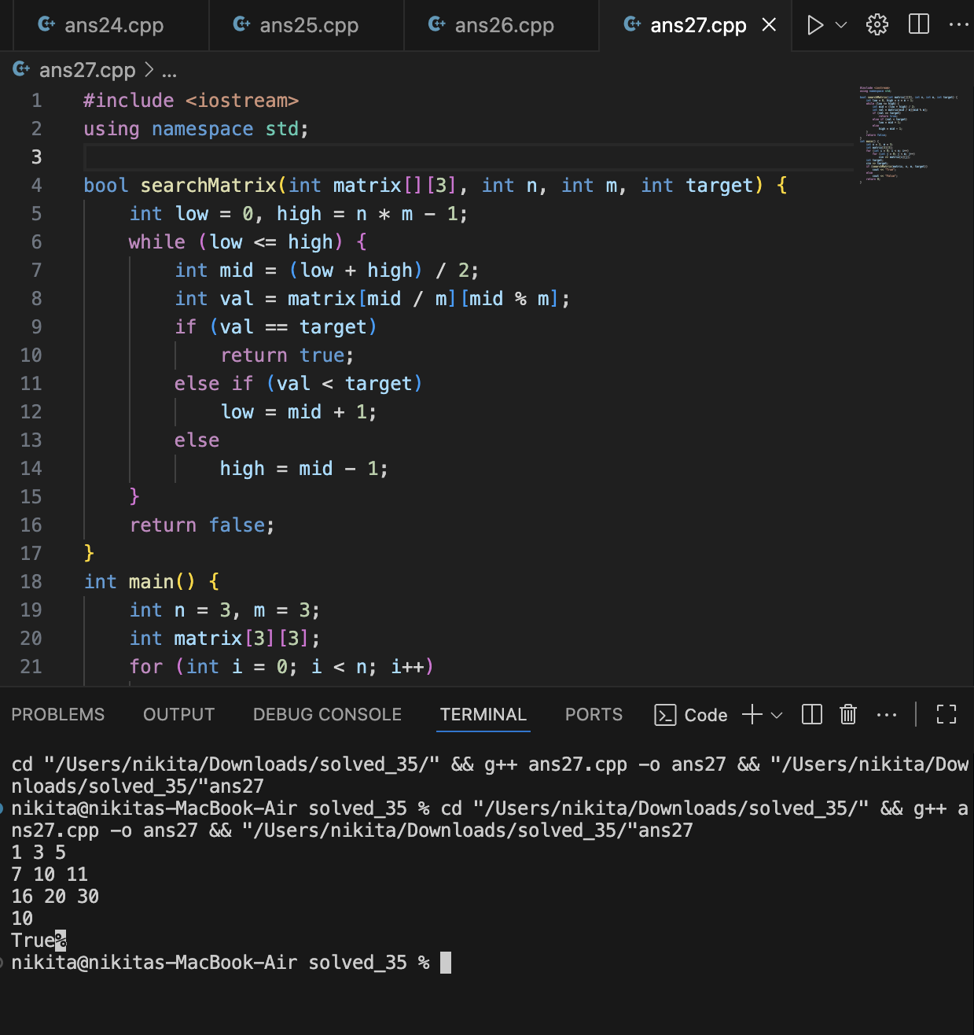

28.THE QUEEN’S JEWELS(BINARY SEARCH FIRST OCCURENCE)

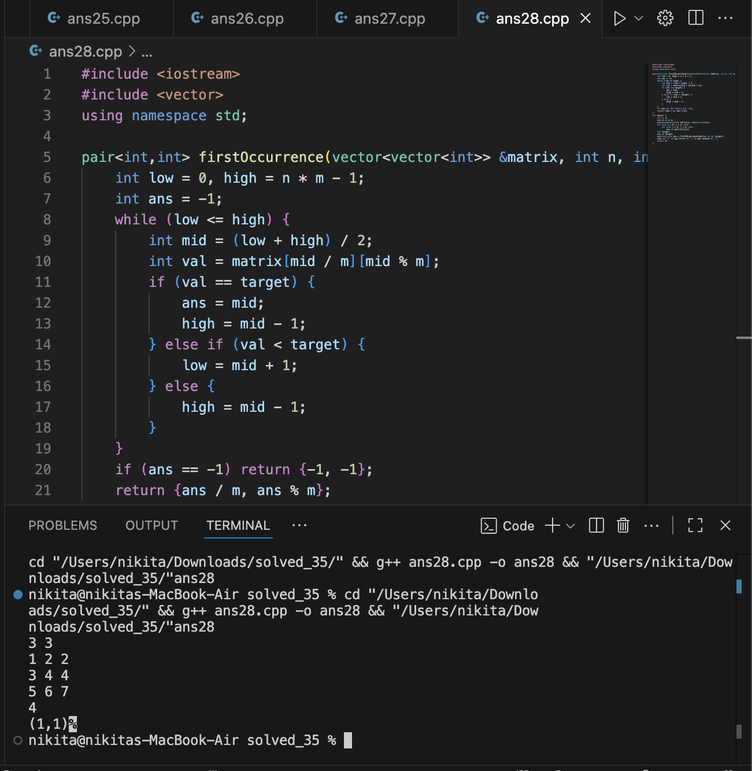

29. THE HIDDEN SCROLLS (STAIRCASE SEARCH)

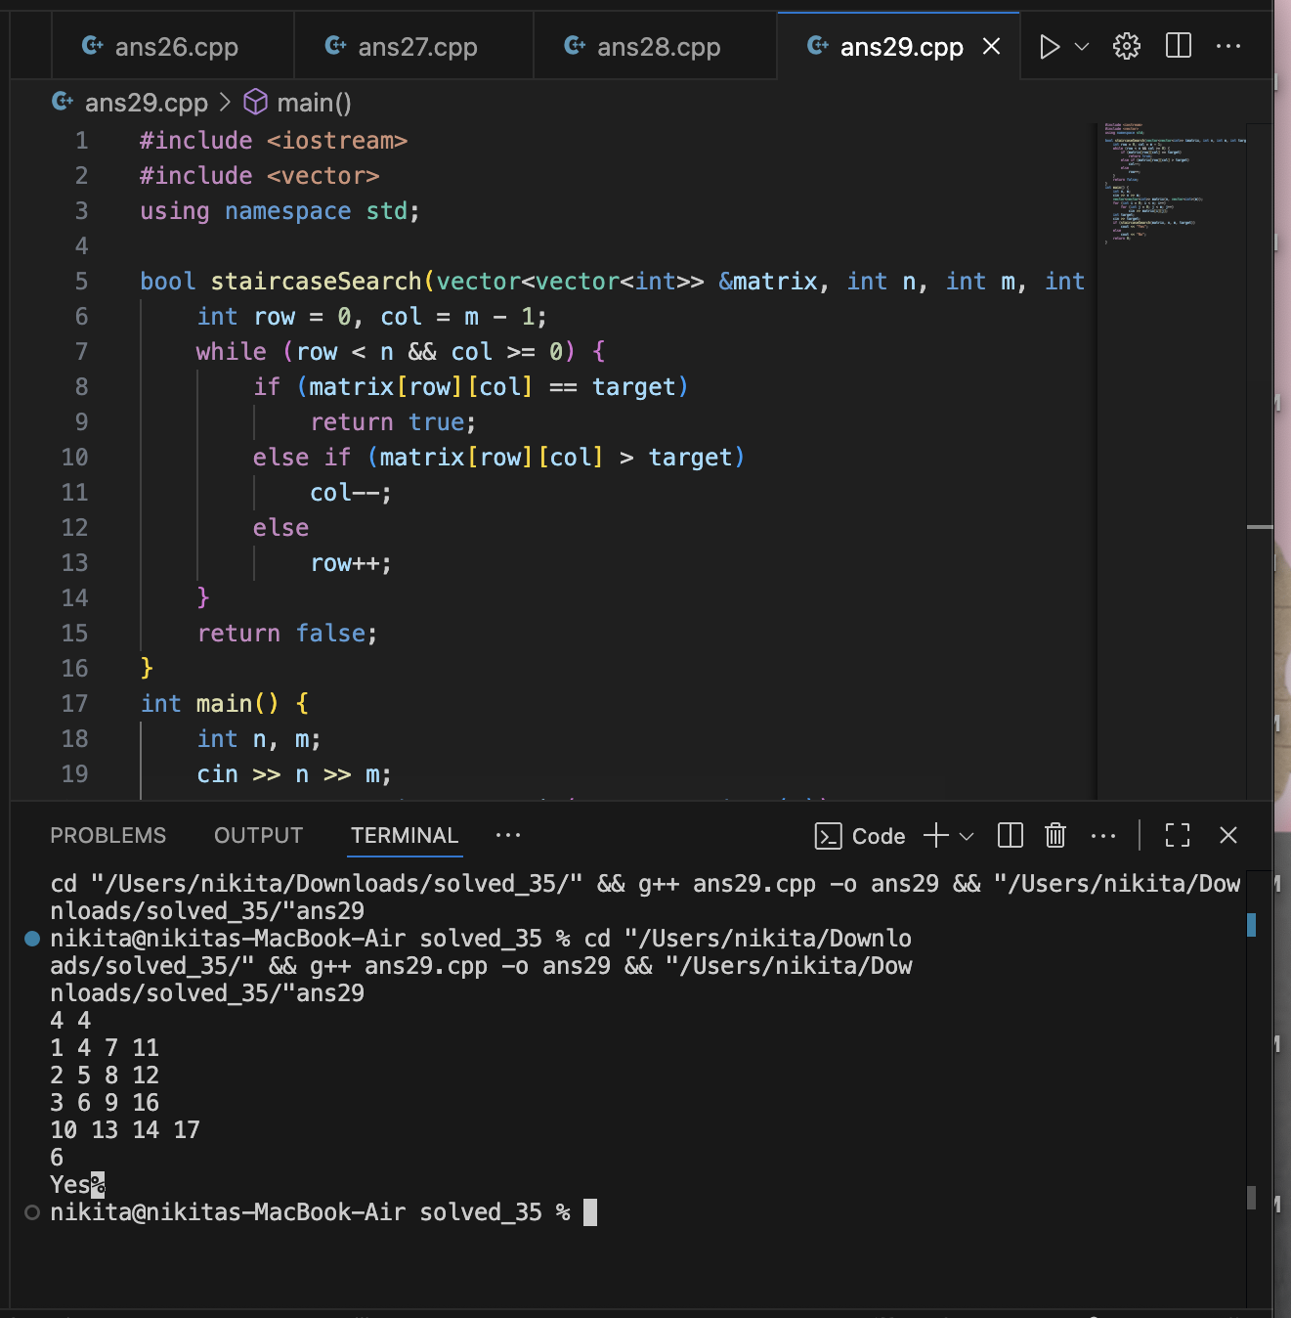

30. THE MAGIC PORTAL (BINARY SEARCH 2D)

